- UK private sector regular pay growth continued to soften in April, despite upward pressure from the month's national living wage increase. With labour market conditions continuing to cool, we expect pay growth to weaken further in the coming months, allowing the Monetary Policy Committee to begin cutting interest rates later this summer.
- Elsewhere, GDP growth was flat in April, after strong gains in each of the three previous months. Though q/q GDP growth in Q2 is likely to be a bit softer than Q1, the recovery should strengthen in H2. Still, with this week's election manifestos confirming the next parliament will see a significant tightening of fiscal policy, the recovery will be steady rather than spectacular.
While April's large overshoot for services inflation had all but ruled out a June rate cut, this week's labour market release promised to have an influence on whether the Monetary Policy Committee would be able to kick off the rate cutting cycle later in the summer. The MPC has consistently focused on pay growth as an indicator of inflation persistence, and April's data included the impact of the month's near-10% increase in the national living wage.
In the event, we saw little that would prevent the MPC from cutting rates later in the summer. Headline (three-month average of the annual rate) private sector regular pay growth – one of the MPC's preferred measures of inflation persistence – continued to slow, falling to 5.8% in April from 5.9% in March (Chart 1).
The impact of the higher NLW was clear – pay growth was strongest in industries where NLW coverage is greatest. We suspect the impact of the NLW rise was smoothed over the first four months of the year, reflecting the timing of firms' annual pay reviews, rather than falling exclusively in April. This would explain the strength of previous months and April's outturn being softer than some other economists had expected. With further base effects set to come into play in the coming months, we think April's data leaves pay growth on track to meet the BoE's Q2 projection. Indeed, it may even come in slightly lower.
Chart 1: Pay growth eased slightly in April, while labour market conditions continued to cool
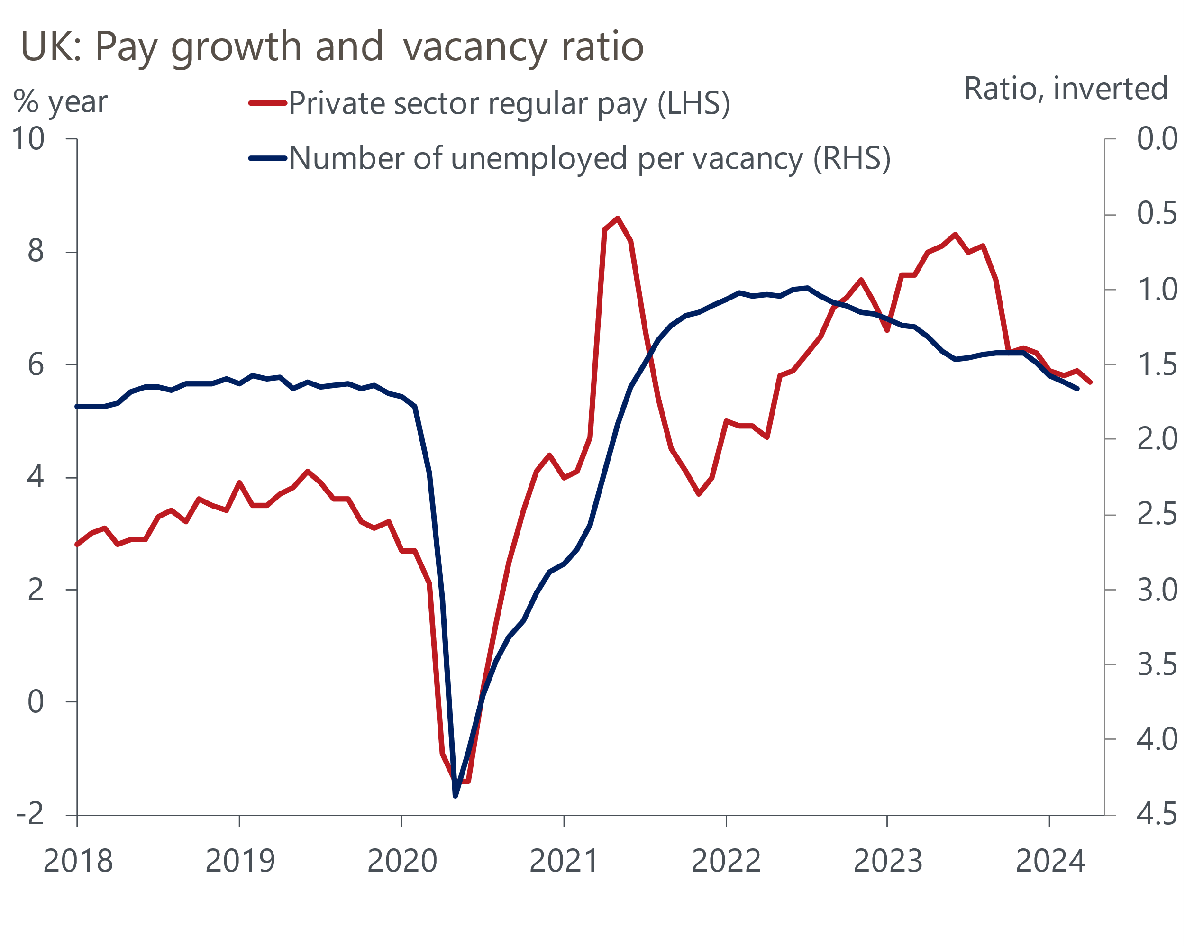
Source: Haver Analytics

Elsewhere in the jobs market release, there was evidence of a further loosening in labour market conditions. We largely discount the Labour Force Survey data given its ongoing problems with small samples. Vacancies and HMRC's PAYE measure of employees continued to fall in May, though the declines in both were more modest than in recent releases, suggesting the pace at which labour demand is cooling may be starting to moderate.
We will get a better idea of whether a majority on the MPC still think rate cuts are coming soon when the committee publishes the minutes of its June meeting next week. But given the MPC has previously expressed its concern about the potential impact of April's large NLW rise, this week's pay data removes an obstacle to future rate cuts. Provided the incoming data releases fall roughly in line with the BoE's staff forecasts, we think the MPC will start to cut rates at the August meeting.
This week's other key release was the GDP data for April. Though GDP was flat, this outturn was better than we had expected given some payback looked likely after very strong growth in March and over the start of 2024 more broadly. Digging into the details, one-off factors, including unseasonably wet weather and the impact of an earlier-than-usual Easter, were a key part of the story in April. A sharp fall in retail sales meant that the consumer-facing services sector weighed most heavily on overall output, while activity in the manufacturing and construction sectors also declined. But these impacts were offset by stronger output elsewhere in the services sector (Chart 2).
Chart 2: Another robust month in the business services sector offset lower consumer activity in April
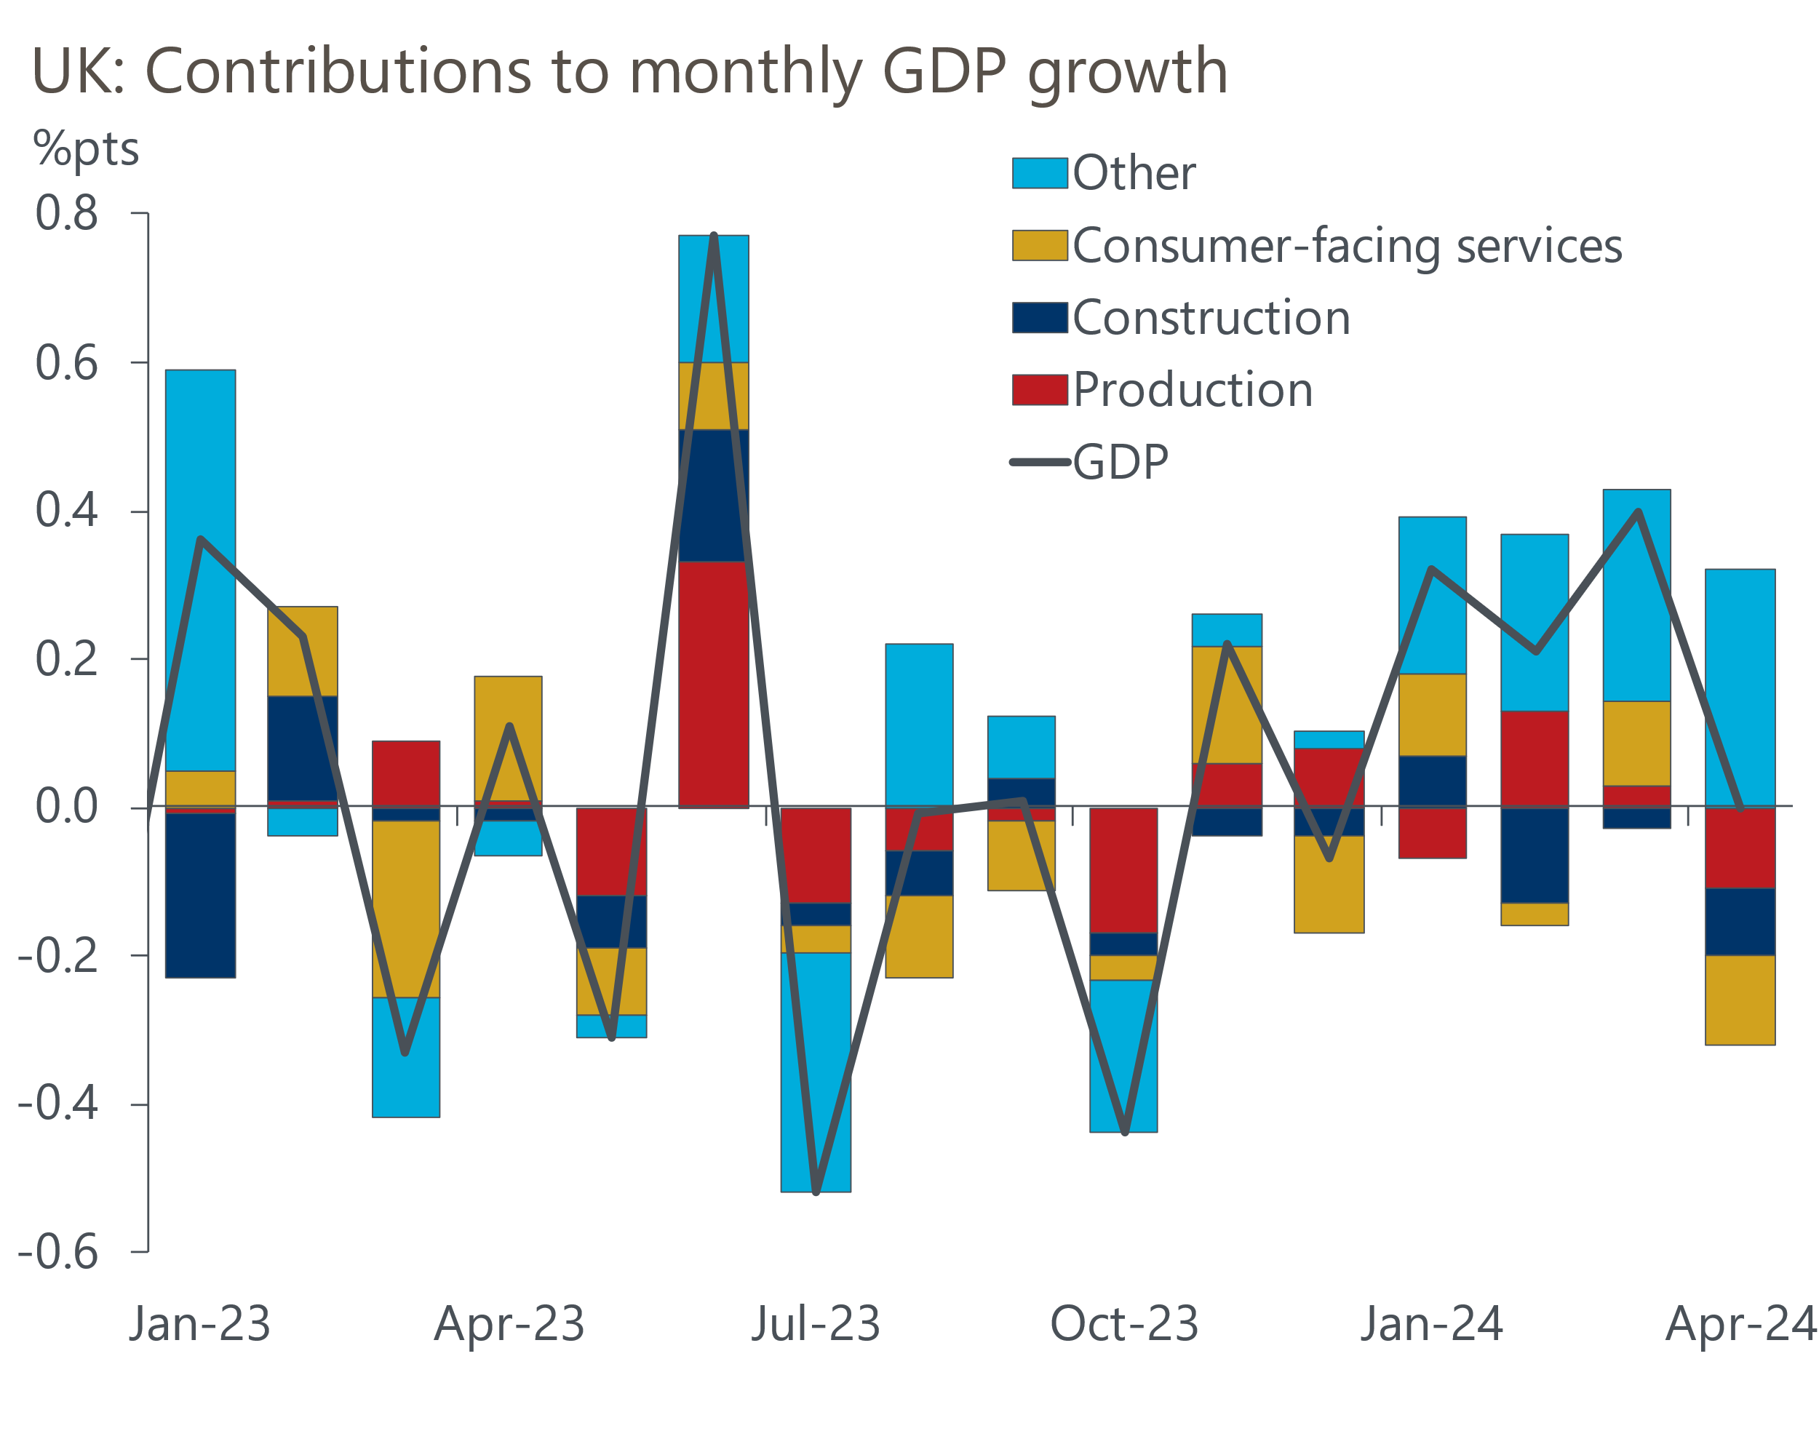
Source: Haver Analytics
Monthly GDP is a very noisy series, which makes it difficult to interpret. We think the underlying story is that the economic recovery is gradually becoming more firmly entrenched. Some of the temporary factors which dragged on GDP in April should unwind soon and the timelier business survey data continues to send positive signals about the momentum in the private sector. We expect GDP to grow at a solid pace this quarter, albeit probably more slowly than in Q1. In the longer term, rising real incomes and consumer confidence point to stronger growth as we move through the rest of this year and into 2025.
But tighter fiscal policy is likely to mean the recovery is steady rather than spectacular. With the general election now three weeks away, the major political parties published their manifestos this week. The pledges from the two main parties reflected where their priorities lie between minimising the increase in the tax burden (Conservatives) or easing the squeeze on the funding of public services (Labour). But the differences were small, particularly in the context of the tightening of fiscal policy that will be inherited from the outgoing administration. And neither manifesto appropriately addressed the dire state of the public finances, or offered policies that are likely to materially alter growth prospects. Still, we have run the proposals from the main parties through our Global Economic Model and next week we will publish a research briefing outlining our view of their potential economic impact.

The week ahead
Next week will see a rapid succession of economic data releases, but the Bank of England's June MPC meeting will take centre stage. Projections by BoE staff have acted as informal benchmarks against which we can measure incoming data that matters to the MPC. Given April's services inflation outturn overshot the BoE staff forecast by such a wide margin, we think it's unlikely that the MPC would contemplate cutting rates at the June meeting. We expect the committee will vote 7-2 to keep Bank Rate at 5.25% and use June's minutes to send a clear message that April's inflation data has only delayed the start of, not derailed, the rate cutting cycle.
Following a series of adverse supply shocks in recent years, we think CPI inflation will have finally dropped back to 2% in May. This would be the first reading to meet the BoE's target since July 2021. The bulk of the downward pressure in May is likely to have come from the food and core categories, where base effects and the indirect effects of lower energy prices continue to weigh on the annual headline inflation rate.
Though retail sales fell sharply in April, this largely reflected the earlier Easter and poor weather which reduced footfall in stores. We expect sales volumes to have fully rebounded in May, as they did after December's similarly unexpected slump. Moreover, the CBI and BRC surveys both pointed to a stronger retailing performance in May. As a result, retail sales are forecast to rise 2.3% in May.
Finally, the forward-looking balances in May's S&P Global PMI surveys suggest June's flash survey is likely to report another broad-based pickup in activity. May's manufacturing survey reported that new orders grew at their fastest pace in over a year, so we expect production levels to strengthen and the flash manufacturing PMI to rise to 51.5 in June. And though the PMI fell in May's services survey, firms in the sector reported stronger expectations for future business activity growth, so we think June's flash services PMI will edge up to 53.1. This would leave the flash composite PMI at around 53.3.
Table 1: Week ahead calendar
Date | Events | Period | Measure | Unit | Previous | Forecast
Jun 19 | CPI inflation | May | m/m | % | 0.3 | 0.3
Jun 19 | CPI inflation | May | y/y | % | 2.3 | 2.0
Jun 19 | RPI inflation | May | m/m | % | 0.5 | 0.6
Jun 19 | RPI inflation | May | y/y | % | 3.3 | 3.2
Jun 19 | Producer input prices | May | m/m | % | 0.7 | 0.0
Jun 19 | Producer input prices | May | y/y | % | -1.5 | -0.2
Jun 19 | Producer output prices | May | m/m | % | 0.2 | 0.1
Jun 19 | Producer output prices | May | y/y | % | 1.1 | 1.8
Jun 20 | BoE Bank Rate decision | Jun | Bank Rate | % | 5.25 | 5.25
Jun 21 | Public finances | May | PSNB ex | £bn | 20.5 | 15.4
Jun 21 | Retail sales inc fuel | May | m/m | % | -2.3 | 2.3
Jun 21 | Retail sales inc fuel | May | y/y | % | -2.7 | -0.2
Jun 21 | S&P Global manufacturing | Jun | PMI | % bal | 51.2 | 51.5
Jun 21 | S&P Global services | Jun | PMI | % bal | 52.9 | 53.1
Jun 21 | S&P Global composite | Jun | PMI | % bal | 53.0 | 53.3
Source: Oxford Economics

Key forecasts
Table 2: UK forecast overview
(Annual percentage changes unless specified)
 | 2022 | 2023 | 2024 | 2025 | 2026 | 2027
GDP | 4.3 | 0.1 | 0.9 | 2.0 | 1.9 | 1.6
Private consumption | 4.8 | 0.2 | 0.7 | 2.6 | 2.2 | 1.6
Fixed investment | 8.0 | 2.2 | -0.5 | 0.8 | 2.7 | 2.1
Government consumption | 2.3 | 0.5 | 3.4 | 2.8 | 1.6 | 1.5
Exports of goods and services | 9.0 | -0.5 | -0.9 | 2.7 | 2.3 | 1.7
Imports of goods and services | 14.6 | -1.5 | 0.2 | 4.7 | 2.9 | 1.9
Industrial Production | -3.5 | -0.4 | 0.3 | 0.9 | 1.5 | 1.1
Consumer prices | 9.1 | 7.3 | 2.5 | 2.5 | 2.3 | 2.2
Unemployment rate (%) | 3.9 | 4.0 | 4.3 | 4.0 | 3.8 | 3.8
Current a/c balance (% of GDP) | -3.1 | -3.3 | -2.7 | -3.2 | -3.2 | -3.1
Government balance (% of GDP) | 4.4 | 5.0 | 3.7 | 3.2 | 2.4 | 1.5
Cen. bank policy rate (%, EOP) | 3.50 | 5.25 | 4.75 | 3.75 | 2.75 | 2.00
10yr govt. bond yield (%, EOP) | 3.67 | 3.54 | 4.00 | 3.66 | 3.18 | 2.85
Exchange rate (US$ per £, EOP) | 1.20 | 1.27 | 1.26 | 1.27 | 1.30 | 1.32
Exchange rate (euro per £, EOP) | 1.13 | 1.15 | 1.17 | 1.17 | 1.17 | 1.16
Source: Oxford Economics
Table 3: Quarterly forecasts for the UK
 | 2024 |  |  |  | 2025
 | Q1 | Q2 | Q3 | Q4 | Q1 | Q2 | Q3 | Q4
GDP (% year) | 0.2 | 0.4 | 1.0 | 1.8 | 1.7 | 2.1 | 2.2 | 2.2
CPI inflation (% year) | 3.5 | 2.1 | 2.0 | 2.5 | 2.5 | 2.3 | 2.6 | 2.4
Bank Rate (%, EOP) | 5.25 | 5.25 | 5.00 | 4.75 | 4.50 | 4.25 | 4.00 | 3.75
10yr gilt yield (%, EOP) | 3.95 | 4.15 | 4.06 | 4.00 | 3.93 | 3.85 | 3.76 | 3.66
US$ per £ (EOP) | 1.26 | 1.26 | 1.26 | 1.26 | 1.26 | 1.26 | 1.27 | 1.27
Euro per £ (EOP) | 1.17 | 1.17 | 1.17 | 1.17 | 1.17 | 1.17 | 1.17 | 1.17
Source: Oxford Economics

Latest Country Economic Forecast:
May 15, 2024

Recent publications

Data Insights
GDP on track for solid growth in Q2
Pay growth continues to cool despite national living wage rise
Weaker services PMI points to less robust activity growth in Q2
Manufacturing PMI jumped to a 22-month high in May
Costlier deals halted the recovery in mortgage approvals

Research Briefings
MPC preview – The clues will be in the language
Will the BoE slow QT?
Why the neutral interest rate will stay structurally low
Why the BoE can and will cut before the Fed
How quickly are indirect effects on core inflation fading?

Contacts

Oxford Economics' UK team
- Andrew Goodwin - Chief UK Economist - agoodwin@oxfordeconomics.com
- Edward Allenby - UK Economist - eallenby@oxfordeconomics.com

